**NAAN MUDHALVAN  
Salesforce Developer(Course)  
Assignment no 1**

­­­Name : ROHINI B

Naan Mudhalvan id : au611220244032

Year & Dep : IV year & Csbs

Batch : 2024   
Zone no : Zone 8

**1. Creating a Master-Detail Relationship between two custom objects and setting up a Roll-Up Summary Field to calculate the total number of records in the child object is a common task in Salesforce. Below are the steps to achieve this:**

**Step 1: Create Custom Objects.**



**Step 2: Create a Master-Detail Relationship**

**1. Go to "Setup" in Salesforce.**

**2. In the Quick Find box, type "Objects" and select "Objects and Fields" > "Objects".**

**3. Click on "Parent" to edit it.**

**4. In the "Custom Fields & Relationships" section, click "New" under "Related To".**

**5. Choose "Master-Detail Relationship" as the data type.**

**6. In the "Related To" field, select "Child".**

**7. Configure other options as needed (e.g., setting the relationship name and whether it's required).**

**8. Save the changes.**

 **Step 3: Create a Roll-Up Summary Field**

**1. In the same "Parent" editing page, scroll down to the "Roll-Up Summary Fields" section.**

**2. Click "New Roll-Up Summary Field."**

**3. Choose the "Child" as the child object for which you want to calculate the total.**

**4. Give your Roll-Up Summary Field a name (e.g., "Total_Child_Records__c").**

**5. Choose the type of calculation you want (e.g., "COUNT").**

**6. Configure any additional filter criteria if needed.**

**7. Save the changes.** **Step 4: Update Page Layouts and Record Types (if necessary)**

**Depending on your use case, you may want to update page layouts and record types to make sure the new relationship and fields are displayed correctly to your users.**

 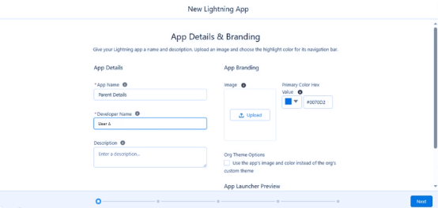

**Step 5: Test the Relationship and Roll-Up Summary Field**

**Create some records in both the Parent and Child objects and verify that the Roll-Up Summary Field correctly calculates the total number of related Child records on the Parent record.**

**That's it! You've successfully created a Master-Detail relationship between two custom objects (Parent and Child) and set up a Roll-Up Summary Field to calculate the total number of records in the Child object.  
  
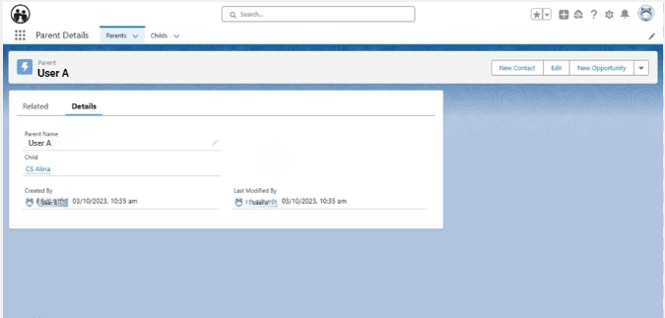**

**2.If there is 2 user, User A and User B in the organisation and we want in Account object that User A should not see the User B Record and user B should not see User A record then apply th Security for the users.**

**Step 1: Create a Public Group**

**1. Go to "Setup" in Salesforce.**

**2. In the Quick Find box, type "Public Groups" and select it.**

**3. Click on "New Public Group."**

**4. Create a group for User A, let's call it "UserA_Group," and add User A to this group.**

**5. Create another group for User B, let's call it "UserB_Group," and add User B to this group.**

 **Step 2: Create Criteria-Based Sharing Rules**

**For User A:1. Go to "Setup" in Salesforce.**

**2. In the Quick Find box, type "Sharing Rules" and select "Sharing Settings."**

**3. Under "Account Sharing Rules," click on "New Sharing Rule."**

**4. Create a rule that shares records owned by members of "UserB_Group" with the "UserA_Group."**

**5. Define the criteria based on which records should be shared (e.g., ownership).**

**6. Save the sharing rule.**

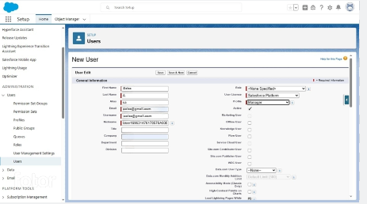

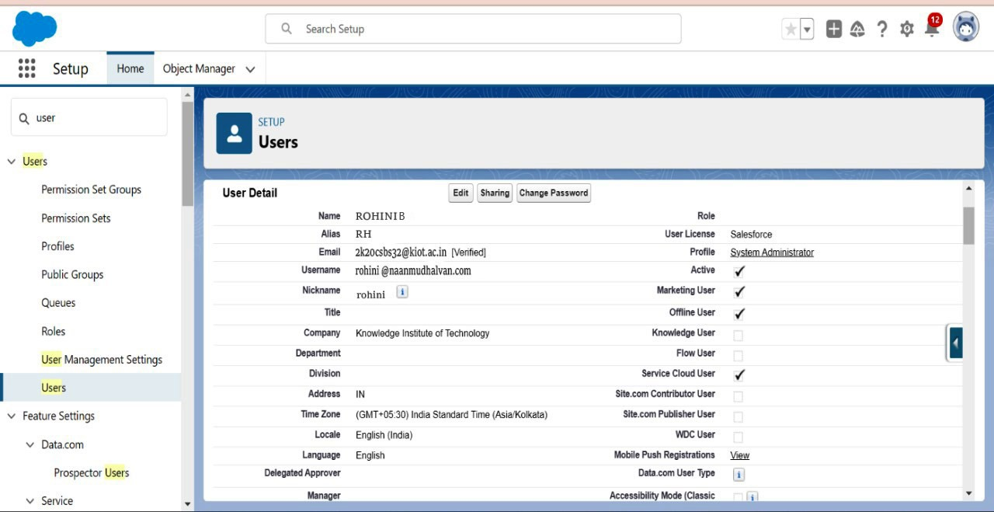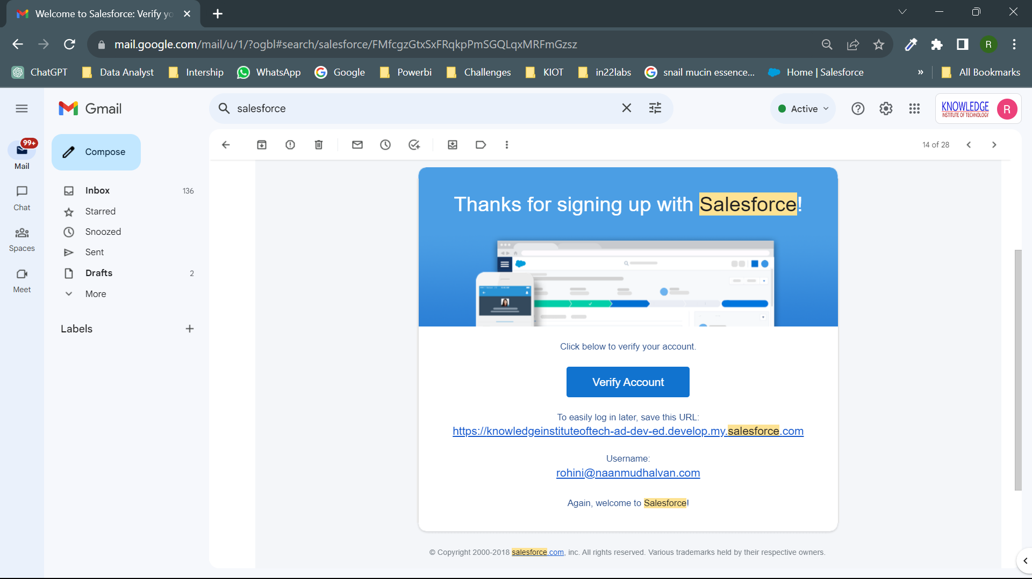

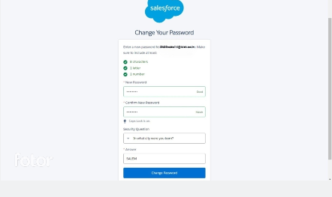 **For User B:**

**1. Follow the same steps as above but create a separate sharing rule for User B.**

**2. This rule should share records owned by members of "UserA_Group" with the "UserB_Group."**

**3. Define the criteria based on which records should be shared.**

**4. Save the sharing rule.  
  
  
Step 3: Assign Records Ownership**

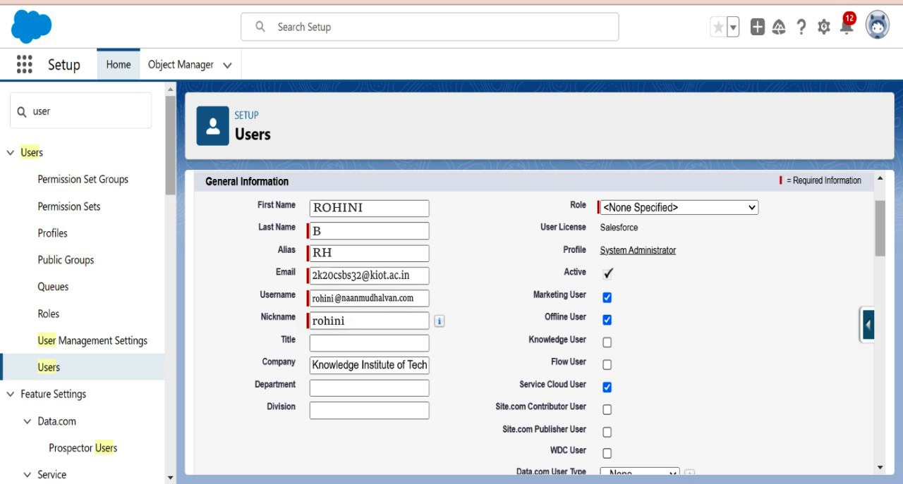

 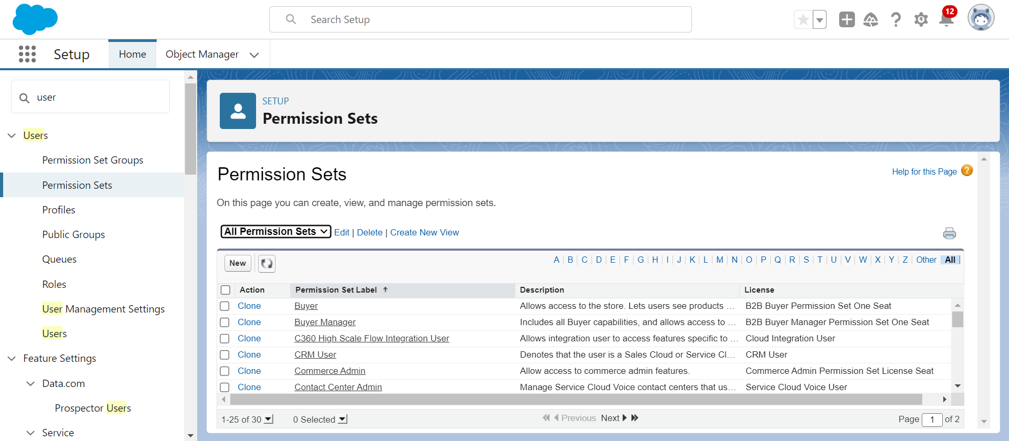 **3.Suppose there are 2 Users and they are having Create, Read, Edit access on Account Object with the same profile but we want to open up the access for one user to delete how will you implement the Security setting.  
Step 1: Create a Permission Set for Delete Access**

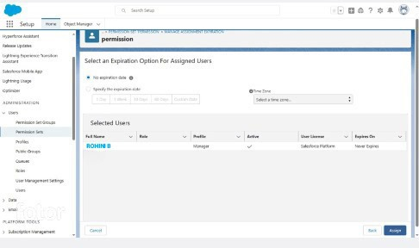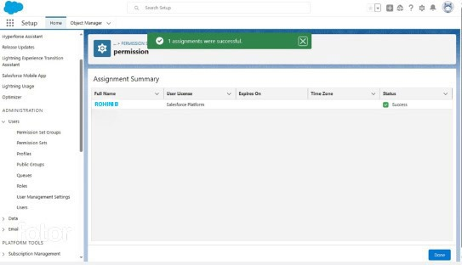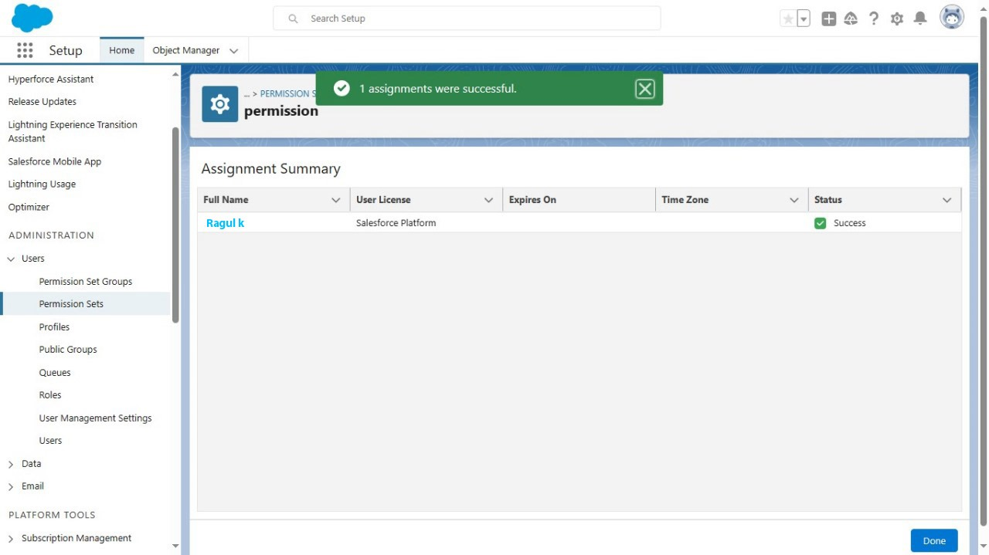

**1. Go to "Setup" in Salesforce.**

**2. In the Quick Find box, type "Permission Sets" and select it.**

**3. Click "New Permission Set" to create a new one.**

**4. Give the permission set a name (e.g., "Delete Access Permission Set").**

**5. In the "System Permissions" section, find and enable the "Delete" permission for the "Account" object.**

**6. Save the permission set.**



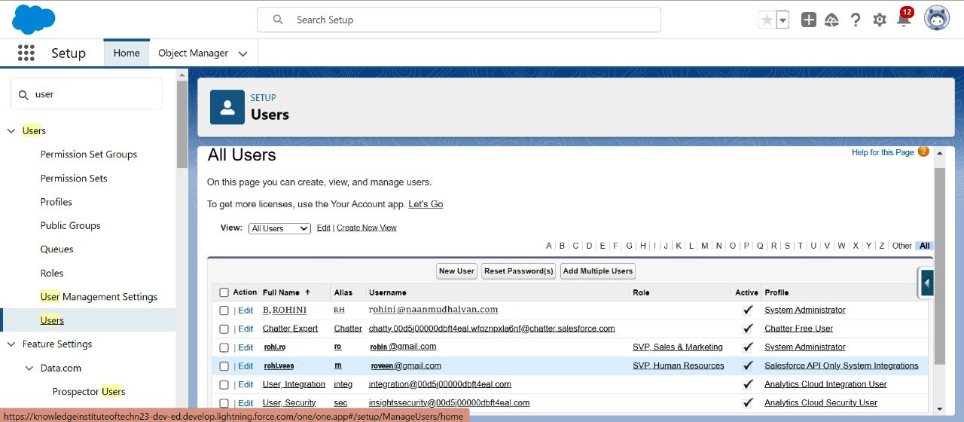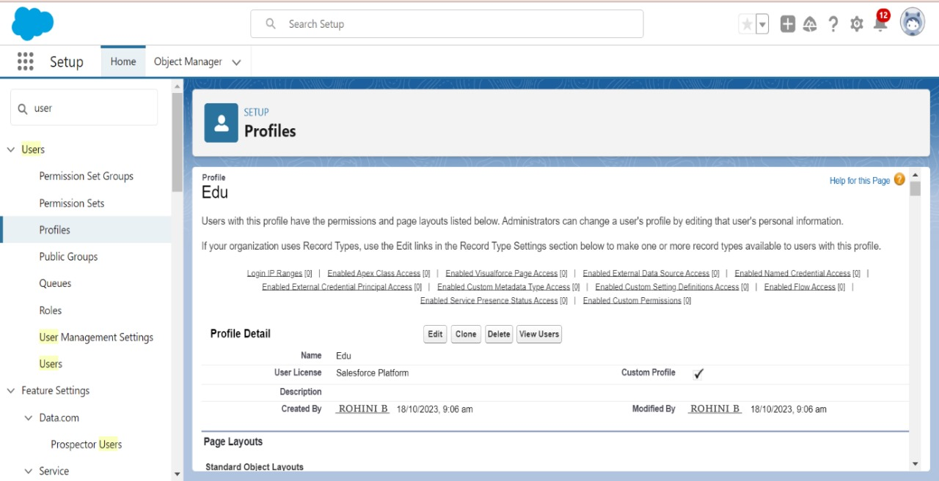

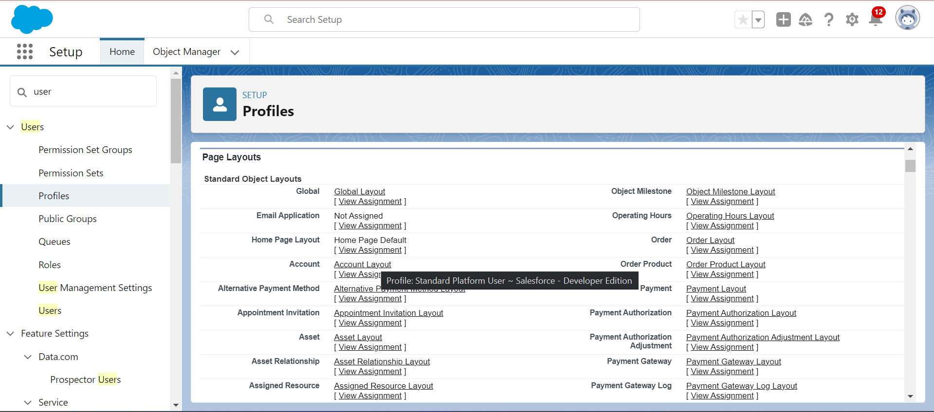 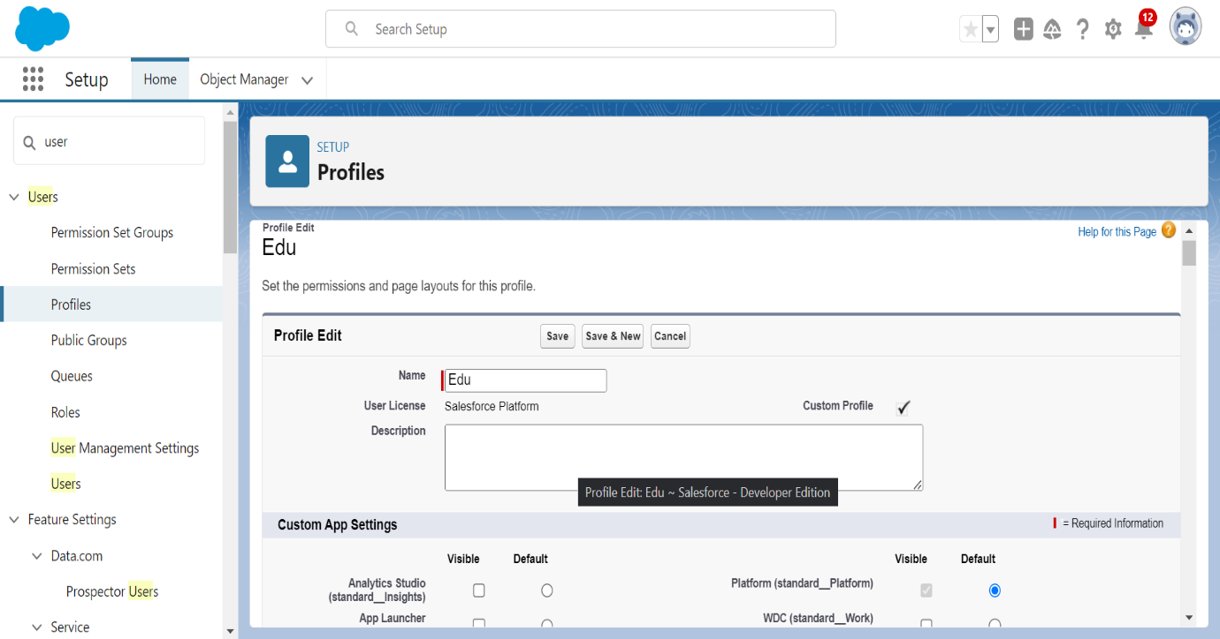



**Step 2: Assign the Permission Set to the User Needing Delete Access**

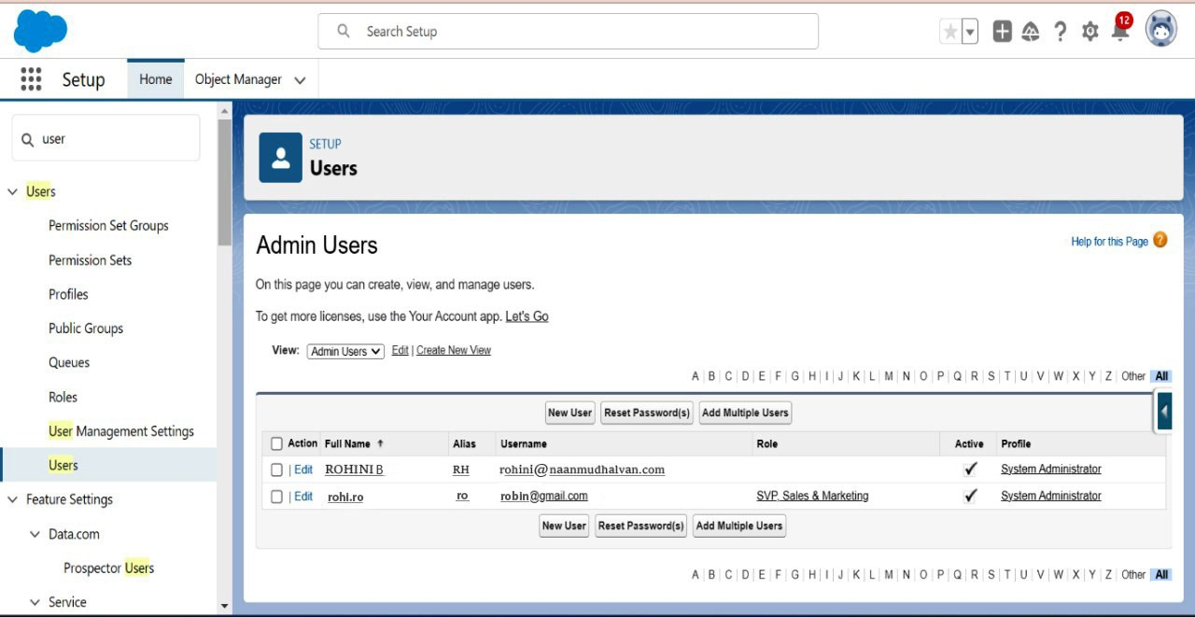

**1. In the "Permission Set Detail" page, click on "Manage Assignments."**

**2. Click "Add Assignments" and select the user who needs delete access.**

**3. Save the assignment.**

**4.Create a screen flow for a basic survey to fill in the details for any form.  
  
Step 1:** Create a custom object  
1.Click Setup.  
2.In the Object Manager, click Create | Custom Object.  
3.Now create a custom object Survey Result and fields as shown in the screenshot below:  
4. Click Save.

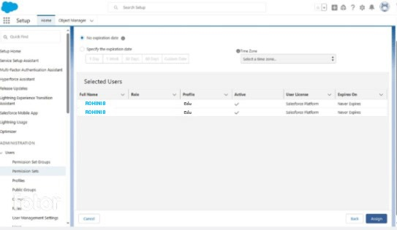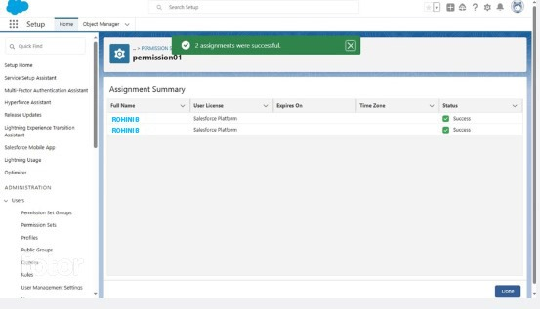



**Step 2: Create a Thank You For Survey Lightning Email Template**

1.Click App Launcher.  
2.In the Quick Find box, type Email Templates.  
3.Clicks on the New Email template button.   
4.Name the Lightning Email Template and make sure to store it in the Public Email Templates folder.  
5.Create a template like the following screenshot

 **Step 3: Create an Email Alert**1.Click Setup.  
2.In the Quick Find box, type Email Alerts.  
3.Select Email Alerts, click on the New Email Alert button.   
4.Name the Email Alert and click the Tab button. The Unique Name will populate.   
5.For Object select Survey Result.  
6.For the Email Template chooses Lightning Email Template Thank You Email – Survey.   
7.For Recipient Type select Email Field: Email.  
8.Click Save.  


**Step 4.1: Salesforce Flow – Create a Screen that Allow Users to Fill Survey**1.Click Setup.  
2.In the Quick Find box, type Flows.  
3.Select Flows then click on the New Flow.  
4.Select the Screen Flow option and click on Next and configure the flow as follows:   
5.How do you want to start building: Freeform  
6.We will use the Screen element to capture a Survey response form. Drag and drop a Screen element onto the canvas.  
  
**Step 4.2: Salesforce Flow – Add a Record Creates Element to Save Survey Response**1.Drag-and-drop the Create Records element onto the Flow designer. 2.Enter a name in the Label (Save Response) field; the API Name will auto-populate.  
3.For How Many Records to Create – select One.  
4.For How to Set the Record Fields – select Use separate resources, and literal values.  
5.Select the Survey_Result__c object from the dropdown list.  
6.Set Field Values for the Survey Result  
  
Row 1:  
Field: Comment__c  
Value: {!Comment}  
Click Add Row  
  
Row 2:  
Field: Email__c  
Value: {!Email.value}  
Click Add Row  
  
Row3:  
Field: Name__c  
Value: {!Name.firstName} {!Name.lastName}  
Click Add Row  
  
Row 3:  
Field: Rating__c  
Value: {!Rating}  
  
7.Click Done.

  
  
  
**Step 4.3: Salesforce Flow – Call an Acton – Email Alert to Send Out Thank You Email**

1.Under Toolbox, select Element.   
2.Drag-and-drop Action element onto the Flow designer.   
3.In the Action box, type Survey – Thank You Email.  
4.Clicks on the Survey – Thank You Email email alert.   
5.Click Done.

  
  
  
  
  
  
  
**Step 5: Create a Lightning Application to Render Lightning Runtime for Flow in a Visualforce Page**

Now we will create a Lightning Application that declares a dependency on the lightning:flow component.  
1.Click Setup | Developer Console  
2.Navigate to File | New | Lightning Application   
3.Enter a Name (VFPageToLC) field, make sure to select the Lightning Out Dependency App checkbox.  
4.Click Submit.  
5.Copy code from GitHub and paste it into your Lightning Application. 6.Save your code.   
  
  
  
  
  
  
**Step 7: Create a Force.com Site to Open Your Flow for Unauthenticated Access**

Now we will create a site to open the flow for unauthenticated access. 1.Click Setup.  
2.In the Quick Find box, type Sites.  
3.Clicks on the New button.  
4.Fill the details as per the screenshot below:   
5.Click Save.  
  
  
Under site, Public Access Settings make sure that guest users have Create access on Survey Result object and Edit on the fields.

Proof of Concept

Now onward, if someone opens the site url and fills the form:

After successful submission, he/she will receive an email.

Row 1:

Field: Comment__c

Value: {!Comment}

Click Add Row

Row 2:

Field: Email__c

Value: {!Email.value}

Click Add Row

Row 3:

Field: Name__c

Value: {!Name.firstName} {!Name.lastName}

Click Add Row

Row 3:

Field: Rating__c

Value: {!Rating}

Click Done.